
College of Engineering
Electrical and Computer Engineering Department
CCEE 454 – Computer Networks
Fall 2025

Project Report:
Campus Departments System Network Design

Project Report Submitted by:
Yara Ismail– 20230321
Nour Zoghat – 20210428
Anthony Abou Merhi– 20220568

Project Report Submitted to:
Ms. Amal El Arid

25 November, 2025

Section 1: Network Topology

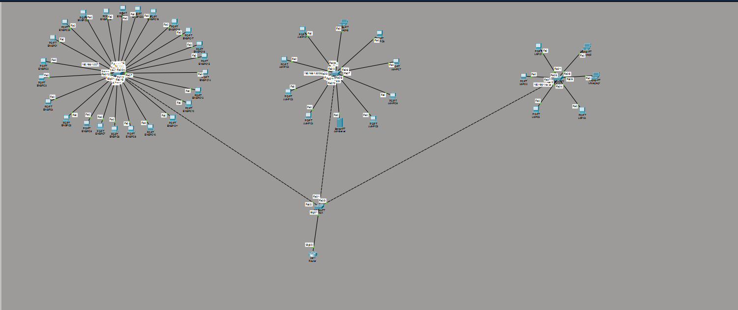

Section 2: Full Addressing Table
Device Name | Interface | IP Address | Subnet Mask | Default Gateway | MAC Address
Router | G0/0.10 | 192.168.1.1 | 255.255.255.224 | N/A
Router | G0/0.20 | 192.168.1.33 | 255.255.255.240 | N/A
Router | G0/0.30 | 192.168.1.49 | 255.255.255.240 | N/A
EngPC1 | Fa0 | 192.168.1.2 | 255.255.255.224 | 192.168.1.1 | 0002.4A73.0A85
AdmPC1 | Fa0 | 192.168.1.34 | 255.255.255.240 | 192.168.1.33 | 000B.BE8A.17D6
AdmLaptop | Fa0 | 192.168.1.43 | 255.255.255.240 | 192.168.1.33 | 0002.168A.696B
AdmServer | Fa0 | 192.168.1.40 | 255.255.255.240 | 192.168.1.33 | 000C.85E9.2938
LibPC1 | Fa0 | 192.168.1.50 | 255.255.255.240 | 192.168.1.49 | 00E0.B0DC.99CC

Section 3: Objectives
The University Campus’s network is designed with scalability, efficiency, and security in mind, ensuring seamless communication between all 3 departments. Each department has its own local area network (LAN) connected through dedicated switches each, which are then integrated into the overall network via a switch that is connected to a single router. The following is a breakdown of the network infrastructure:
Engineering LAN:
Department: Engineering
Devices:
- 24 PCs as workstations
- 1 Switch for communication within the network and the router.

Administration LAN :
Department: Administration
Devices:
- 8 PCs as workstations
- 1 Laptop
- 1 Server
- 1 Switch for communication within the network and the router.

Library LAN:
Department: Library
Devices:
- 4 PCs as workstations.
- 2 laptops
- 1 Switch for communication within the network and the router.

This hierarchical network design ensures efficient traffic management, simplifies troubleshooting, and provides room for future expansion as the departments grows.

Section 4: Network Design
The campus’s network design incorporates various networking devices to ensure seamless connectivity and communication across the three departments. Below is a detailed list of the devices used and their specifications, as per the provided topology image:

First Department Devices (Engineering):
The engineering department network includes 24 PCs as workstations, all configured to receive IP addresses via static. All devices are connected to a switch which serves as an intermediary between the devices and the switch that is connected to the router. The router manages static addressing and functions as the network gateway, with an IP address of 192.168.1.1
Second Department Devices (Administration):
The Administration department network includes 8 PCs as workstations, 1 Laptop and 1 Server, all configured to receive IP addresses via static. All devices are connected to a switch which serves as an intermediary between the devices and the switch connected to the router. The router manages static addressing and functions as the network gateway, with an IP address of 192.168.1.33
Third Department Devices (Library):
The Library department network includes 4 PCs as workstations and 2 Laptops, all configured to receive IP addresses via static. All devices are connected to a switch, which links them to the router. The router manages static addressing and functions as the network gateway, with an IP address of 192.168.1.49

Section 5: Implementation Description
Router configuration
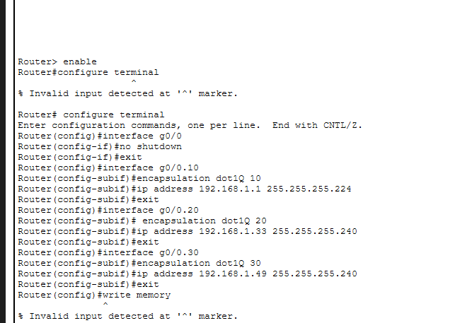
Central switch configuration
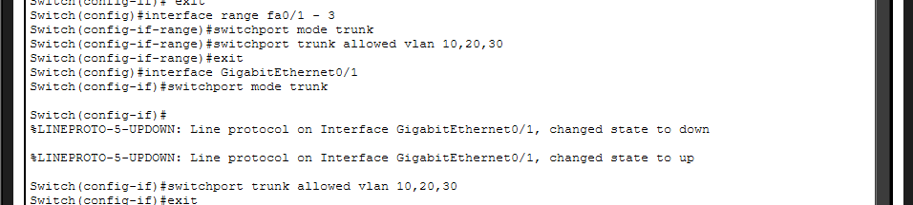

Department switches
Engineering switch configuration
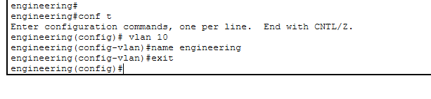

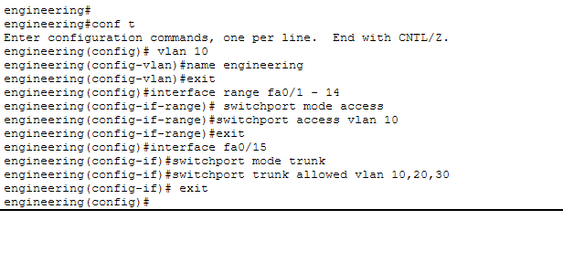
Administration switch configuration 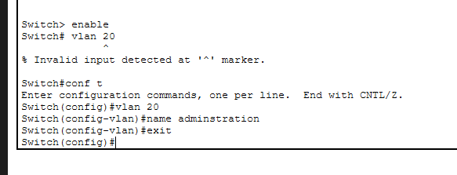
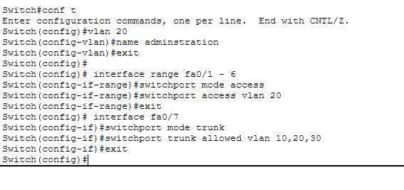

Library switch configuration

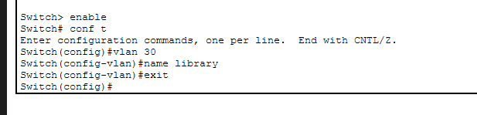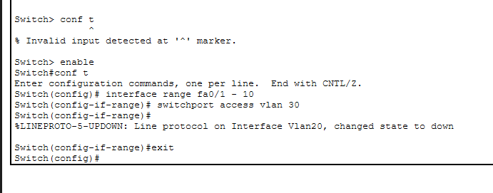

Section 6: Connection Verification
After setting up the network, we wanted to make sure everything was working smoothly, so we ran a few key tests:
Ping Test:
First, we ran ping tests between the PCs on the same department to check if they could communicate with each other. Then, we pinged the PCs to the web sever to ensure the web server was accessible to all pcs . To check if the network was working between departments, we also pinged devices across the switches . This helped us confirm that the devices on different departments were able to connect and communicate without any issues.

Engineering pc ping test and web server accesses
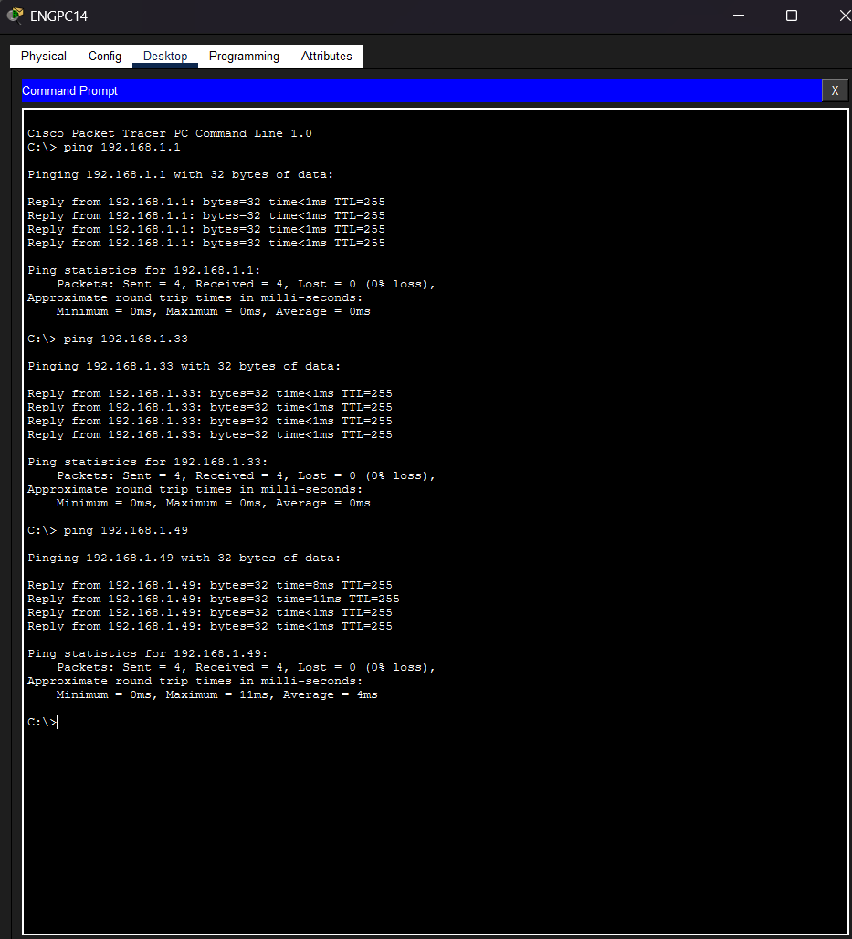

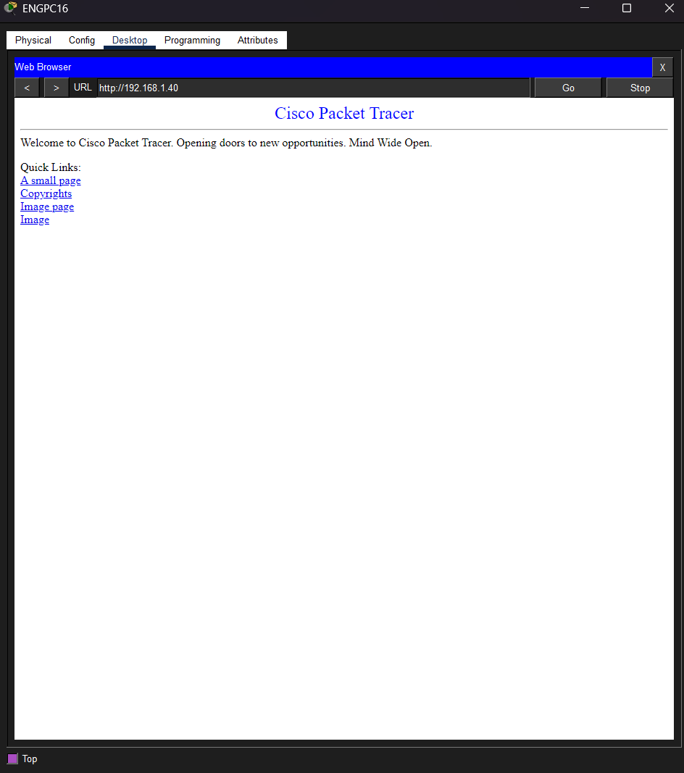

Administration pc ping test and web server accesses
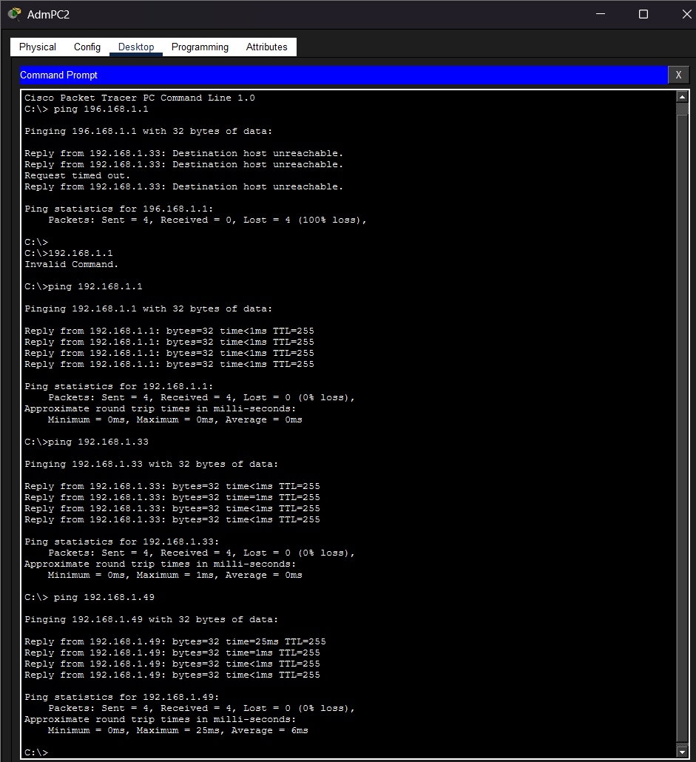
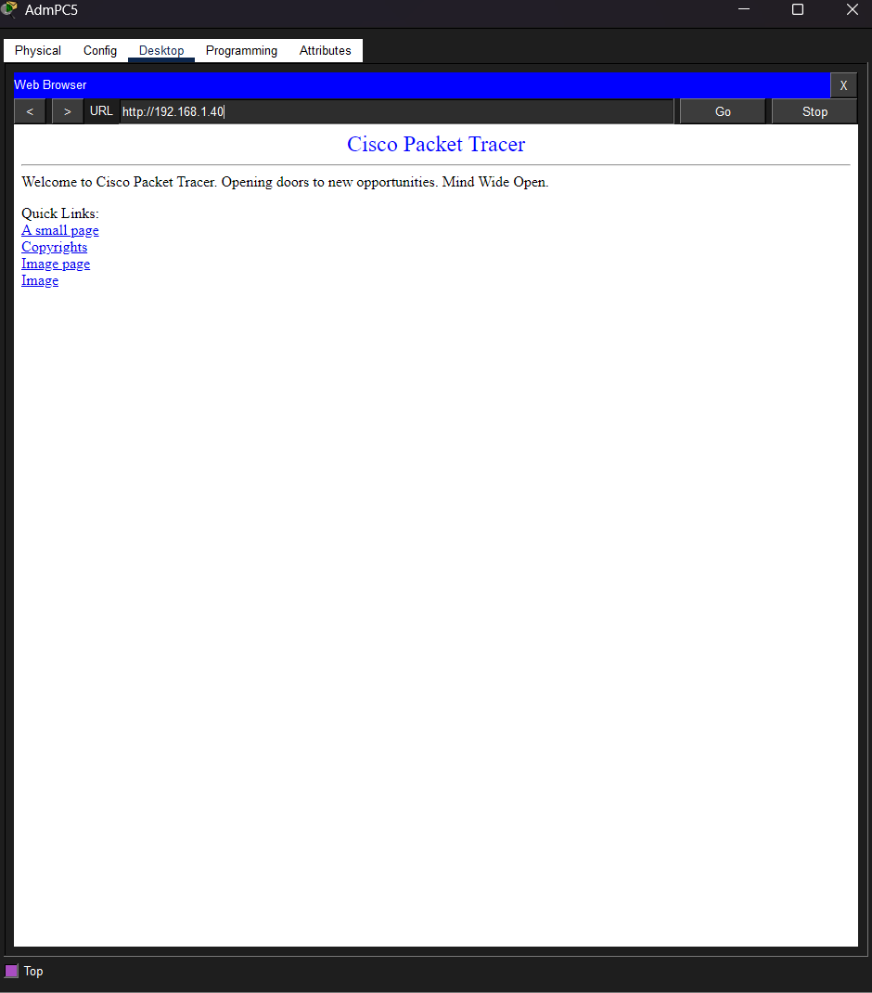

Library pc ping test and web server access
